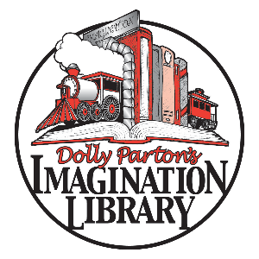
FAQs
Pulaski County Imagination Library is offering FREE BOOKS to kids from
birth up to five years old who live in Pulaski County. PCIL is an affiliate of the
Dolly Parton Imagination Library, a nonprofit book gifting program that mails
free books to children in participating communities.

If you have additional questions, contact Hannah Vogler Manus at admin@pcaril.org or 501-425-2626.

Q: Does my child have to attend ___________ to participate in the Imagination Library?
A: No! Any child under the age of five who lives in Pulaski County is eligible.
Q: Can I share this registration form with family and friends?
A: Yes! Any eligible child can sign up using this form. Extra forms are available on the Pulaski County Imagination Library website at www.pcaril.org.
Q: How do I receive books?
A: Books will be mailed to your child at the address provided on the registration form.
Q: When do books arrive?
A: It takes about 6-8 weeks for your first book to arrive after you return the form.

Q: Do you provide books in languages other than English?
A: Not at this time. However, there are several books each year selected that are bilingual English/Spanish titles.
Q: What if I am or my child is blind or visually impaired?
A: Dolly Parton Imagination Library has partnered with American Printing House for the Blind, Inc. (APH) to make many of the wonderful books in her program available in braille and audio format for young blind and visually impaired children. You can register for the program here: http://www.aph.org/dolly-partons-imagination-library/apply/
Q: What if I don’t live in Pulaski County?
A: Pulaski County Imagination Library only sends books to kids who live in Pulaski County. You can see if there is an Imagination Library in your area on the main Dolly Parton Imagination Library website: https://imaginationlibrary.com/usa/find-my-program

